Functional Test Plan

Emission-Related Components and/or Systems*

The purpose of the functional test plan is to ensure that the emission control system components of California vehicles are assembled correctly and functioning properly.

Dynamic Vehicle Test (DVT)

Emission-related systems controlled by the engine control module (ECM), transmission control module (TCM), and powertrain integration module (PIM) are functionally tested by the dynamic vehicle test (DVT). The DVT is conducted with the vehicle on a roll test machine. There is currently one DVT test sites at the vehicle assembly plant. The DVT test site has a test computer. Each vehicle's ECM/TCM/PIM incorporates a feature which monitors ECM/TCM/PIM activity and produces data showing the status of all sensors and controls that are monitored. The data are fed to the external test computer by means of the vehicle's data link connector (DLC, also known as ALDL) to the test computer. The test computer prompts the test operator by means of a display unit through all required test modes. Test algorithms and parameters which control running conditions within specified ranges are stored in the test system. When monitored sensor or control outputs in the data do not correspond to predetermined response parameters, a fault is indicated.

Successful communication of data to the DVT verifies that the on-board diagnostic system and serial communication link is functioning. The DVT interrogates the vehicle's ECM/TCM/PIM for diagnostic trouble codes. Any diagnostic trouble codes identified during the DVT by the on-board diagnostic (OBD) system, and any "malfunctions" or "faults" identified by the off-board DVT checks, are recorded. All vehicles must pass DVT prior to shipment. A description of the functional test process is shown in Figure 1. The DVT drive cycle / test sequence is shown in Figure 2.

The following systems, components and functions are verified by an off-board computer during DVT.

Air-Fuel Control/Fuel Injectors
The DVT monitors the oxygen sensor and fuel trim values to verify that the closed loop system is functional and air-fuel ratio is in control. If the exhaust is lean or rich to a level that is outside the determined parameters, the DVT will set a "fault." In this way, significant lean conditions such as vacuum leaks and rich conditions such as high fuel pressure or rich injectors are detected. Likewise, if the fuel trim correction is outside the parameters the DVT will set a fault.

Throttle System (Throttle Position Sensor and Pedal Position Sensor)
Sensor voltages are measured and compared to acceptable parameters and must exhibit a large enough delta during the DVT.
___________________________________________________________________
* Not all components/systems are applicable for all products. Please see certification documentation

Engine Coolant Temperature Sensor (ECT Sensor)
The DVT verifies that the ECT sensor output is within acceptable parameters and that the engine can reach and maintain a warm engine condition.

Oxygen Sensors
The DVT verifies that the pre-catalyst oxygen sensor(s) are operating and transitioning between rich and lean states. The DVT verifies that the post-catalyst oxygen sensor(s) are operating within acceptable parameters.

EGR System Test
The DVT verifies the EGR sensor value is within acceptable parameters.

Transmission Shift Solenoids/Stepper Motors
The DVT verifies that the transmission shifts automatically.

Torque Converter Clutch (TCC) System
The DVT verifies the TCC slip value is within acceptable parameters.

Transmission System
The DVT verifies that the transmission shifts automatically.

Vehicle Speed Sensor (VSS)
The DVT verifies that the ECM vehicle speed input is within acceptable parameters as compared to the speed of the roll test machine.

Brake Switch
The DVT verifies that the brake switch status has changed in response to the operator depressing the brake.

Engine Operation
The DVT determines normal engine behavior using data from the engine coolant temperature sensor, manifold absolute pressure sensor, idle air control valve, ignition, and mass air flow sensor to determine if they are within acceptable parameters. Based on all of these inputs, a number of functional checks are conducted, including ignition timing, misfire, electronic spark timing, and fuel injectors.

Other Functional Tests

Some emission-related systems operate independently and are not monitored by the DVT. Various stand-alone tests and inspection operations are used to verify integrity of the systems and components. Other emission-related components or systems do not lend themselves to a functional test in the assembly environment. In such cases, functional testing/verification is required of the supplier.

Evaporative Emission/ORVR System
The suppliers of all enhanced evaporative emissions/ORVR system components, using statistically valid sampling, assure all parts are leak free before they ship (vendor qualified). Visual inspection during assembly is performed to identify wrong routings, pinched or loose connections and disconnections of mechanical, vacuum and electrical items.

Catalytic Converter
The content of catalytic converters is assured by the supplier before shipment. The composition of the catalyst material is verified on a lot basis. In the converter assembly process, converters are 100% tested for freedom from leaks.

Emission-Related Hoses, Tubing, Clamps, Belts, Fittings, Wiring, Connectors, Sensors and Switches
Interconnecting in emission-related systems is functionally verified by respective functional tests on individual systems. In most cases, disconnects or blocked passages inhibit system function and result in "fault" detection in the functional test. The assembly integrity of clamps, hoses, tubing, and belts is subjective and depends on individual assembly operations. Visual inspection during assembly is performed to identify wrong routings, pinched or loose connections and disconnections of mechanical, vacuum, ignition control and electrical items. Various sensors, switches and connectors are either checked independently, vendor qualified, and/or DVT verified.

Thermostat
Each thermostat is functionally checked by the supplier before shipment.
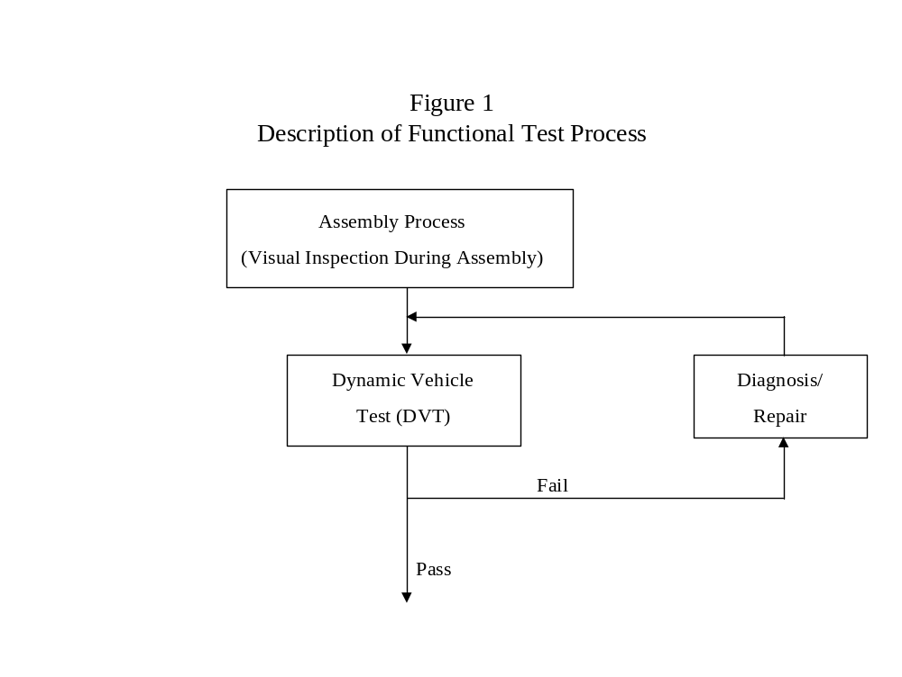

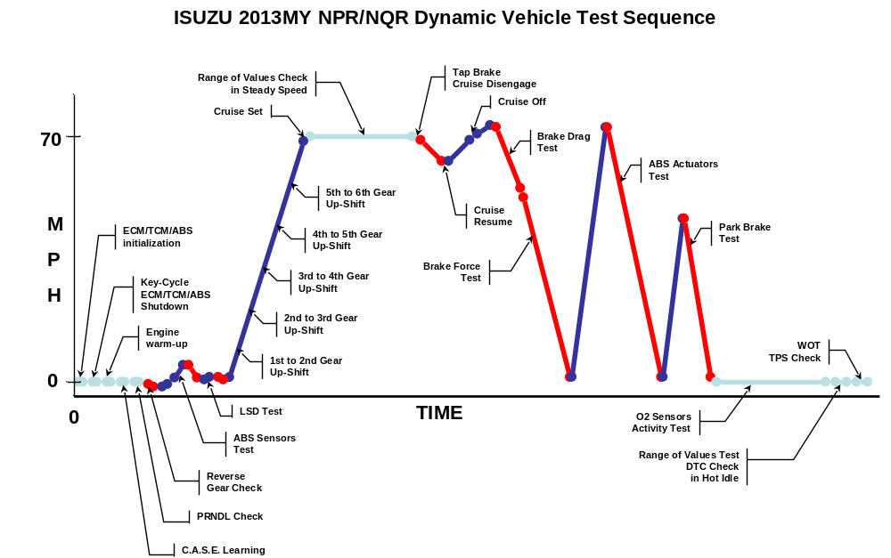
ISUZU 2016MY NPR/NQR Dynamic Vehicle Test Sequence

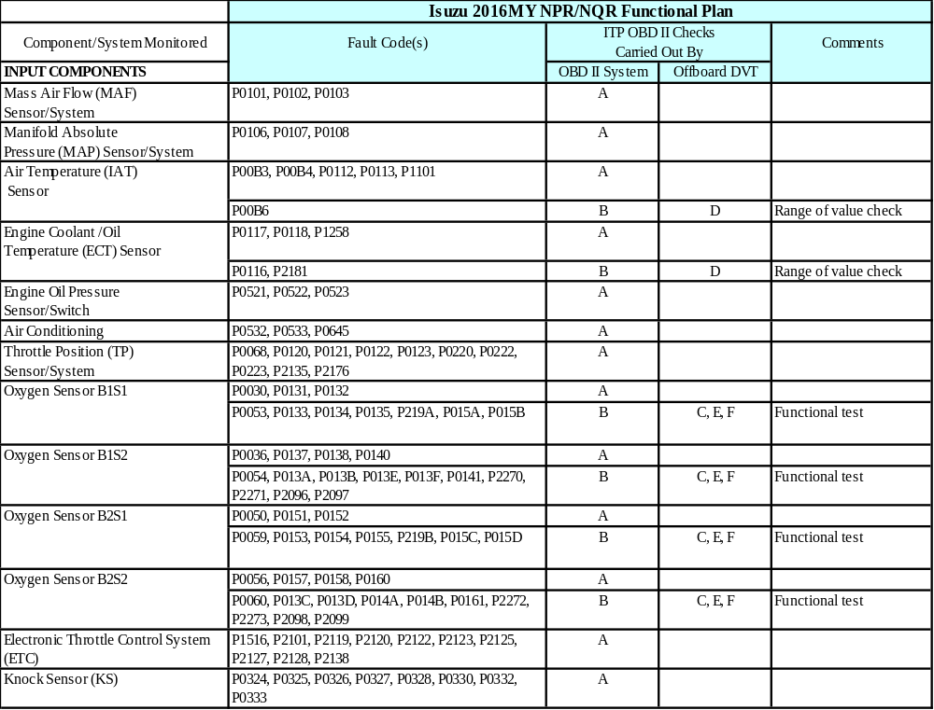
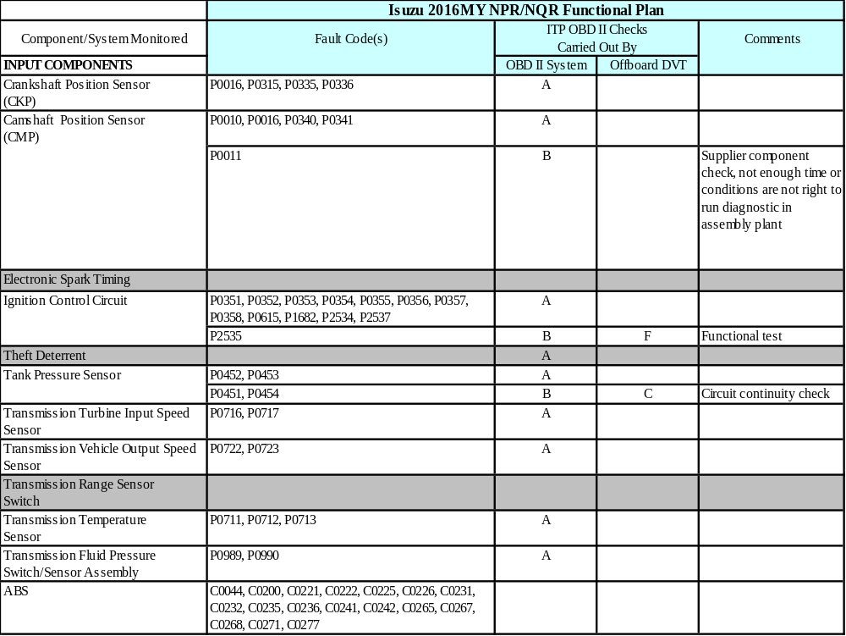
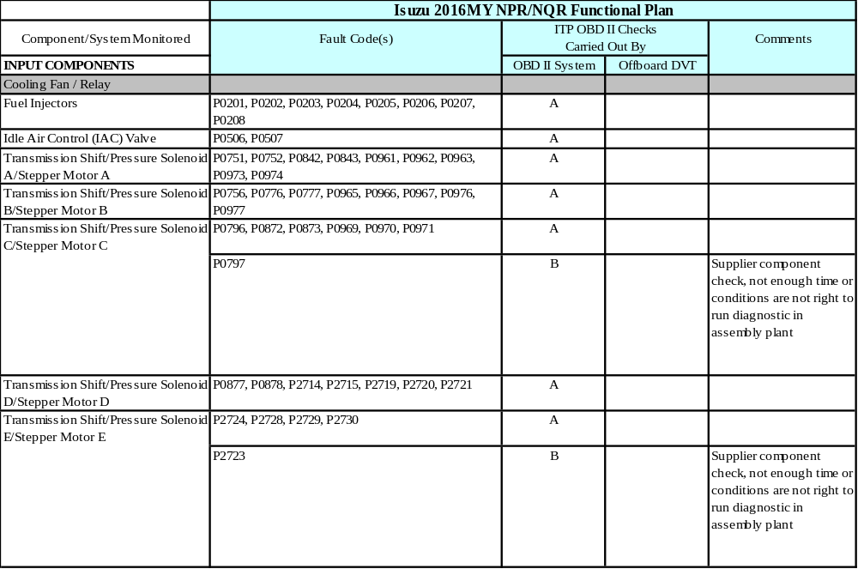

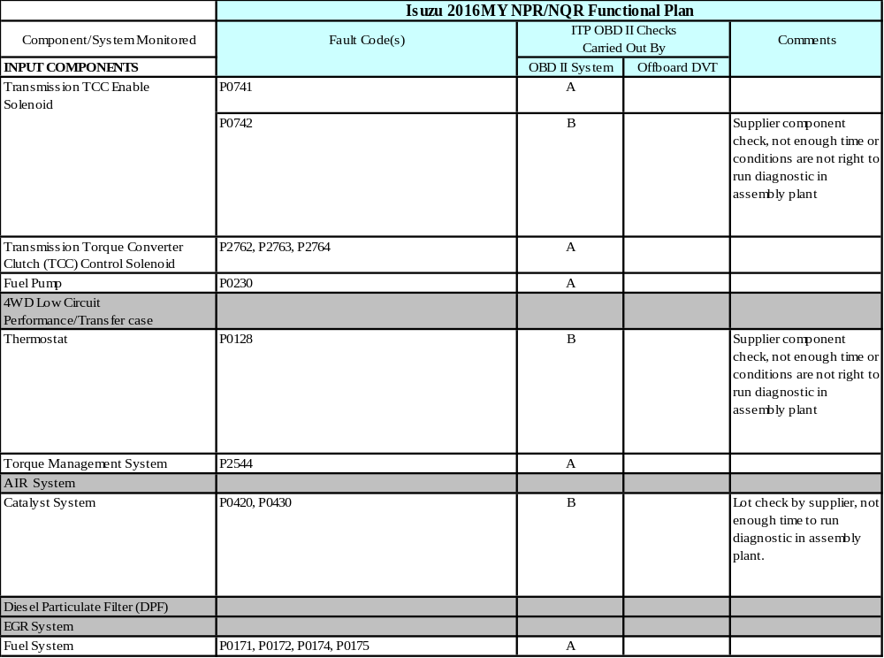
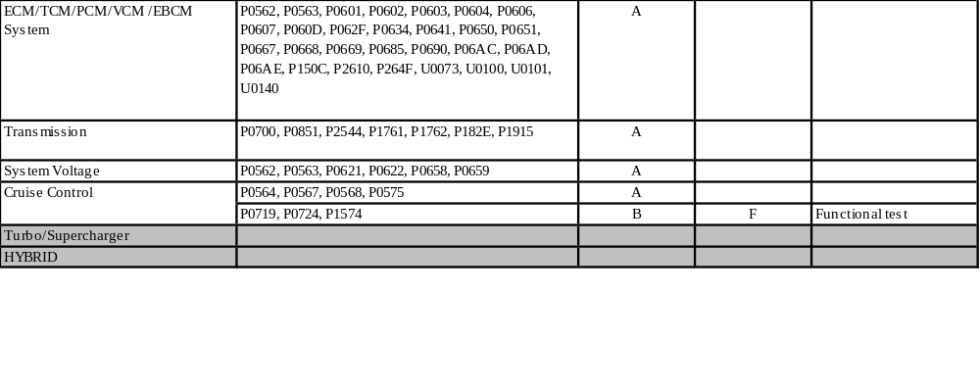

There are no DTC summaries that have been updated from 2015 as shown in the list above. Additions of DTCs to the summaries are usually the result of new components or systems added to one or more ISUZU vehicle lines. Deletion of DTCs from the summaries may be due to the cancellation or replacement of a previously used component or system, communication of components or systems and/or previously different code types, or reclassification of a code type.

